Feature | string s1 = "Hello" | string s1 = new string("Hello")
Memory Allocation | The "Hello" literal is created in a shared memory pool called the string intern pool. | A new object is created on the heap every time this is executed.
Interning | The Common Language Runtime (CLR) automatically checks if the value "Hello" already exists in the intern pool. If it does, s1 points to the existing object. If not, it's added. | This explicitly forces the creation of a new object, regardless of whether "Hello" is already in the intern pool or on the heap.
Reference Equality | If you define two string literals with the same content (e.g., string s1 = "Hello"; string s2 = "Hello";), the s1 == s2 comparison will typically be true because they both reference the same object in memory. | If you define string s1 = new string("Hello"); string s2 = new string("Hello");, the s1 == s2 comparison will typically be false because they point to two distinct memory locations (two different objects on the heap).
Performance | More efficient due to reuse of existing string objects, reducing memory overhead. | Less efficient due to guaranteed extra object creation and memory allocation.
In summary:
- string s1 = "Hello" is the standard, efficient way to create a string in C#. It leverages the string intern pool for optimization.
- string s1 = new string("Hello") forces the instantiation of a brand-new object on the heap, bypassing the performance benefits of string interning and making it a less common practice in standard coding unless a new object reference is specifically required.
- String Comparison with equals() in undefined
String s1 = "Hello"; // Let's say it is stored at memory address 1004. String s2 = "Hello"; // This also points to 1004 because th...

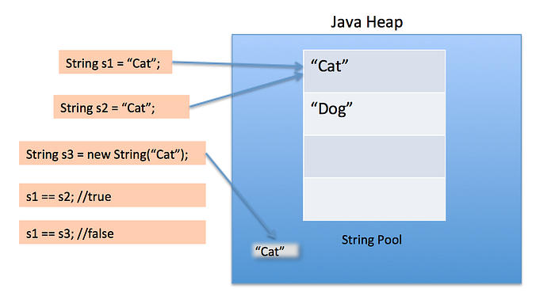

The intern() method in Java is a String class method that returns a canonical representation of a string object by storing it in or retrieving it from the String Constant Pool. It reduces memory usage by ensuring that duplicate strings, especially those created with new String(), share the same memory location, thereby improving performance.
Key Aspects of intern():
- String Pool Management: If the pool already contains a string equal to the current object (as determined by equals(Object)), the string from the pool is returned.
- New Pool Entry: If the string is not in the pool, the current string object is added to the pool, and a reference to it is returned.
- Memory Efficiency: It helps avoid duplicate string objects in heap memory, which is critical for applications handling many repetitive strings.
- Usage: While string literals are automatically interned, intern() is useful for string objects created via new String("...").
- Example: String s1 = new String("Hello"); String s2 = s1.intern(); Here, s2 refers to the literal "Hello" in the pool, not the s1 object on the heap.
Considerations:
- Performance Cost: While it saves memory, interning every string can increase CPU usage due to the overhead of searching the string pool.
- Best Practice: It is best used for optimizing applications with heavy string duplication.

